**CRUD OPERATIONS**

**C→CREATION / INSERT**

**R→REMOVE**

**U→UPDATE**

**D→DELETE**

**CREATION / INSERT : Inserts are the basic method for adding data to**

**MongoDB. To insert a document into a collection, use the collection’s insert method.**

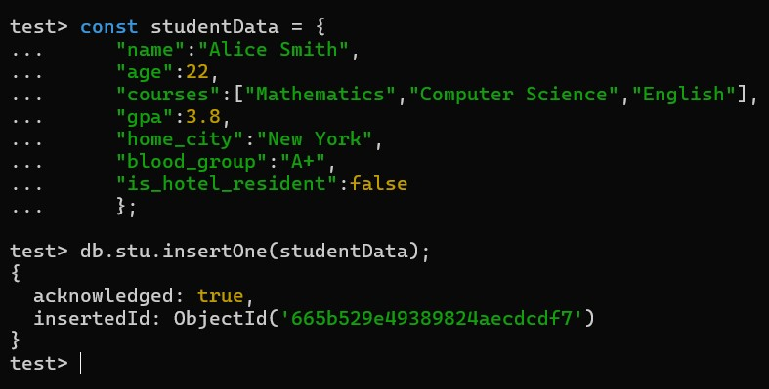

**INSERT ONE() : In MongoDB, insertOne() method inserts a document into the collection. This method inserts only one document at a time.**

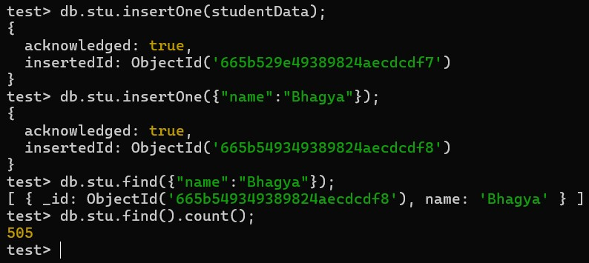

**INSERT MANY(): The insertMany() method inserts one or more documents in the collection. It takes array of documents to insert in the collection.**

**REMOVE : The remove() method removes documents from the database. It can remove one or all documents from the collection that matches the given query expression. If you pass an empty document({}) in this method, then it will remove all documents from the specified collection. It takes four parameters and returns an object that contains the status of the operation.**

**UPDATE : The update() method in MongoDB updates a document or multiple documents in the collection.This method can be used for a single updating of documents as well as multiple documents. By default, the db.collection.update() method updates a single document. To update all documents that match the given query. Include the option “multi: true“. *Note: In MongoDB, the update() method has been deprecated in favor of using*** [***updateOne()***](https://www.geeksforgeeks.org/mongodb-updateone-method-db-collection-updateone/) ***or*** [***updateMany()***](https://www.geeksforgeeks.org/mongodb-updatemany-method-db-collection-updatemany/) ***depending on your specific use case.***

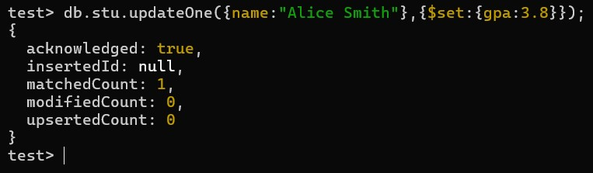

**DELETE : To delete documents from a MongoDB collection, you can use the following methods**

**deleteOne(): deletes a single document from the collection that satisfies the given criteria.**

**deleteMany(): deletes multiple documents from the collection that satisfy the**

**given criteria. remove(): deletes one or all data that matches the search criteria. drop(): deletes a complete collection. dropDatabase(): deletes an entire database.**

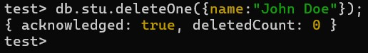

**UPDATE MANY() : The updateMany() method updates all the documents in MongoDB collections that match the given query.**

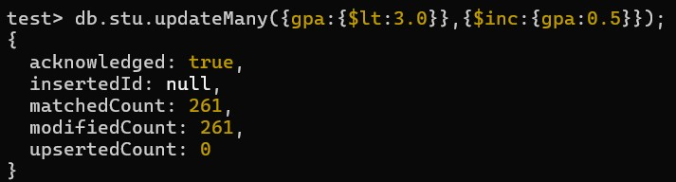

**DELETE : The deleteOne() method in MongoDB deletes the first document from the collection that matches the given selection criteria. It will delete/remove a single document from the collection.**

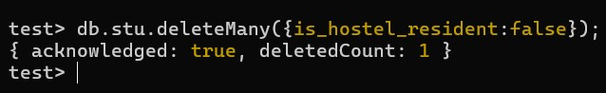

**PROJECTION : MongoDB provides a special feature that is known as**

**Projection. It allows you to select only the necessary data rather than selecting whole data from the document.**

**This is used when we don’t need all columns/attributes.**



**[**

**{**

**_id: ObjectId('6655e91dee1dcfb73e7398a4'), name: 'Student 948', gpa: 4**

**},**

**{**

**_id: ObjectId('6655e91dee1dcfb73e7398a5'), name: 'Student 157', gpa: 2.77**

**},**

**{**

**_id: ObjectId('6655e91dee1dcfb73e7398a6'), name: 'Student 316', gpa: 2.82**

**},**

**{**

**_id: ObjectId('6655e91dee1dcfb73e7398a7'), name: 'Student 346', gpa: 3.31**

**},**

**{**

**_id: ObjectId('6655e91dee1dcfb73e7398a8'), name: 'Student 930', gpa: 3.63**

**},**

**{**

**_id: ObjectId('6655e91dee1dcfb73e7398a9'), name: 'Student 305',**

**gpa: 3.4**

**},**

**{**

**_id: ObjectId('6655e91dee1dcfb73e7398aa'), name: 'Student 268',**

**gpa: 3.98**

**},**

**{**

**_id: ObjectId('6655e91dee1dcfb73e7398ab'), name: 'Student 563',**

**gpa: 2.75**

**},**

**{**

**_id: ObjectId('6655e91dee1dcfb73e7398ac'), name: 'Student 440',**

**gpa: 2.56**

**},**

**{**

**_id: ObjectId('6655e91dee1dcfb73e7398ad'), name: 'Student 536',**

**gpa: 3.37**

**},**

**{**

**_id: ObjectId('6655e91dee1dcfb73e7398ae'), name: 'Student 256',**

**gpa: 3.44**

**},**

**{**

**_id: ObjectId('6655e91dee1dcfb73e7398af'), name: 'Student 177',**

**gpa: 3.02**

**},**

**{**

**_id: ObjectId('6655e91dee1dcfb73e7398b0'), name: 'Student 871',**

**gpa: 3.2**

**},**

**{**

**_id: ObjectId('6655e91dee1dcfb73e7398b1'), name: 'Student 487',**

**gpa: 2.6**

**},**

**{**

**_id: ObjectId('6655e91dee1dcfb73e7398b2'), name: 'Student 213',**

**gpa: 2.89**

**},**

**{**

**_id: ObjectId('6655e91dee1dcfb73e7398b3'), name: 'Student 690',**

**gpa: 2.75**

**},**

**{**

**_id: ObjectId('6655e91dee1dcfb73e7398b4'), name: 'Student 368',**

**gpa: 3.91**

**},**

**{**

**_id: ObjectId('6655e91dee1dcfb73e7398b5'), name: 'Student 172',**

**gpa: 2.96**

**},**

**{**

**_id: ObjectId('6655e91dee1dcfb73e7398b6'), name: 'Student 647',**

**gpa: 3.43**

**},**

**{**

**_id: ObjectId('6655e91dee1dcfb73e7398b7'), name: 'Student 232',**

**gpa: 3.04**

**}**

**]**

**Type "it" for more test>**